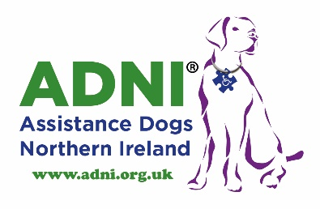 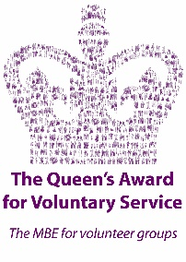

2018

**GIFT AID**

**MAKE YOUR DONATION WORTH EVEN MORE**

**GIFT TO ASSISTANCE DOGS NORTHERN IRELAND**

**NO COST TO YOU**

Gift Aid is a no hassle, low effort way to help Assistance Dogs Northern Ireland.

Using Gift Aid means that for every pound you give, Assistance Dogs Northern Ireland will receive an extra 25 pence from the Inland Revenue, helping your donation go further.

This means that a £10.00 gift can be turned into £12.50, as long as donations are made through Gift Aid. Imagine what a difference that could make and it doesn’t cost you a thing.

Simply complete the form overleaf, tick the Gift Aid declaration box and send it back to Assistance Dogs Northern Ireland.

It’s that simple.

**Assistance Dogs NI**

**15 Connell Street Carpark, Limavady, BT49 0DB.**

**Registered Charity Number NIC102413**

 

2018

**GIFT AID**

**MAKE YOUR DONATION WORTH EVEN MORE**

**Your Details**

|  |  |
| --- | --- |
| **Title** |  |
| **Forename** |  |
| **Surname** |  |
| **Address** |  |
|  |  |
| **Postcode** |  |

|  |
| --- |
| **Declaration**  I want Assistance Dogs Northern Ireland to treat all donations I have made since the __________, and all donations I make from the date of this declaration until I notify you otherwise, as Gift Aid donations.  Signature: ____________________________________  Date: ____________________ |

**Notes**

1. **To qualify for Gift Aid, what you pay in income tax or capital gains tax must be at least equal to the amount we will claim in the tax year.**
2. **You can cancel this declaration at any time by notifying:**

Assistance Dogs Northern Ireland.

1. **Please notify** Assistance Dogs Northern Ireland if you change your name or address.

**Please return to: Assistance Dogs NI, 15 Connell Street Carpark, Limavady, BT49 0DB.**

**Registered Charity Number: NIC102413**