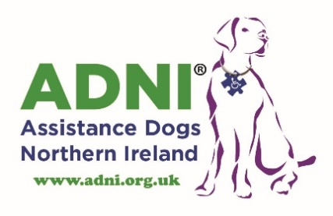 2018
ASSISTANCE DOGS NORTHERN IRELAND
THERAPY DOG REQUEST

Full-Time Therapy Dog Placement

Therapy Dog Visits (When available)

Name of Setting
Address
Postcode
Telephone Number
Website
Contact Made By
Position
Telephone Number
Mobile Number
E-mail Address

Please Circle what is appropriate to your setting
Setting | School | Mainstream: Pre-School  Mainstream: Primary  Mainstream: Secondary  Special Needs School

Setting | Hospital | Children and Young People’s Ward  Older People

Setting | Day Centre | Family Centre  Older People

Please e-mail completed form to: info@adni.org.uk
Send to
Assistance Dogs NI, 15 Connell Street Carpark, Limavady BT49 0DB

